**Sally Oketch**

[sally.oketch@womentechsters.org](mailto:sally.oketch@womentechsters.org)

1. **Creating auntentic.sh**

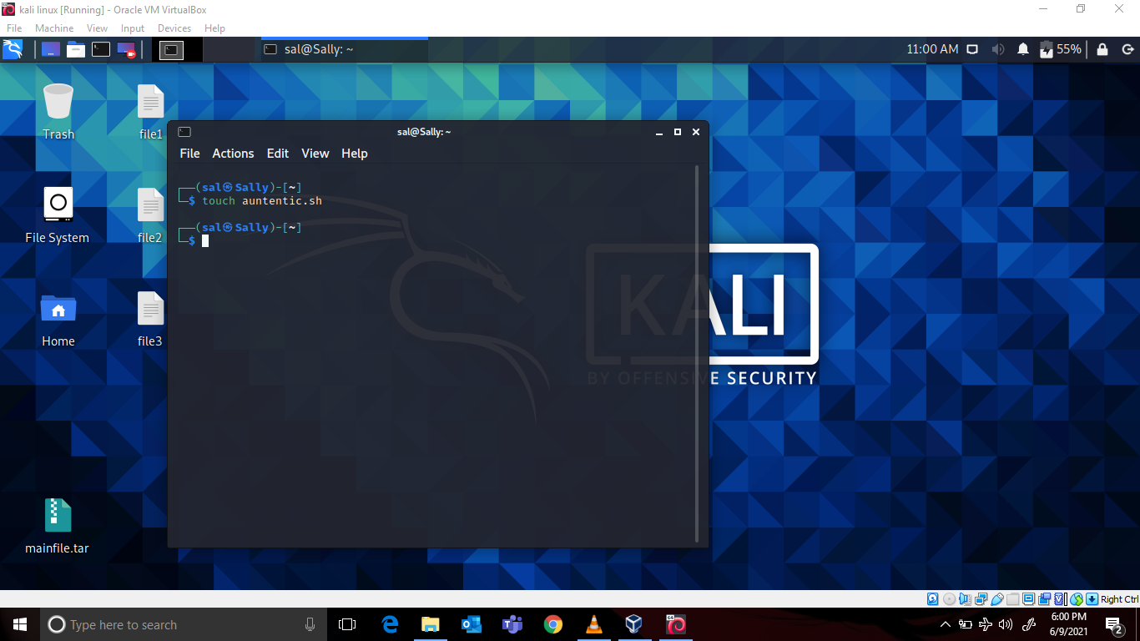

1. **Editing auntentic.sh using nano editor**

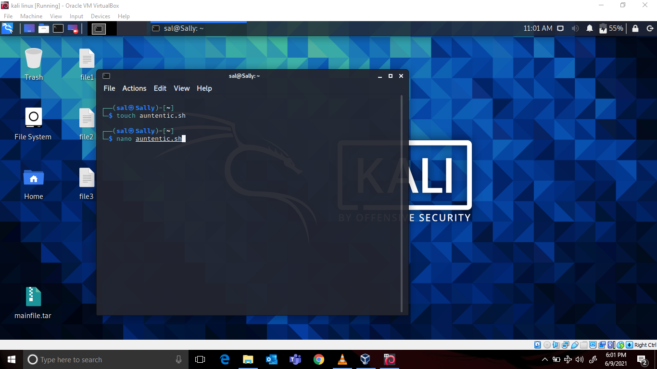

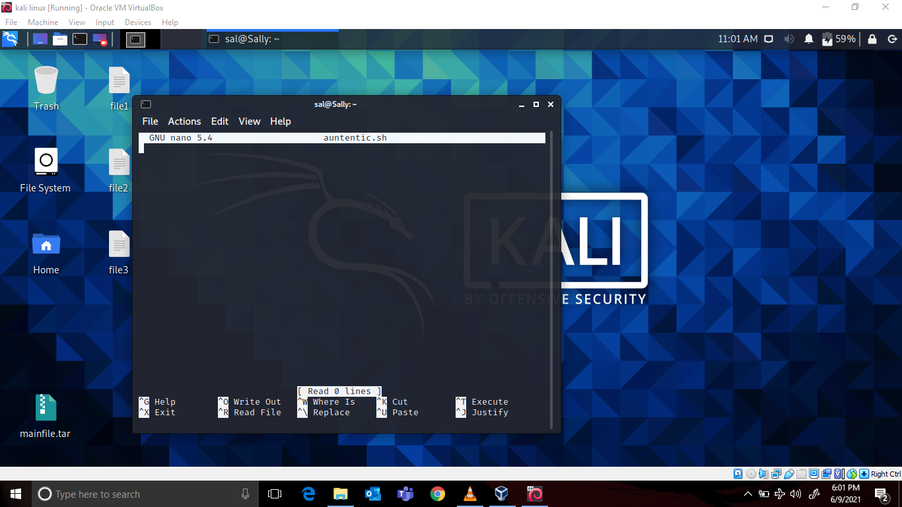

1. **Password strength checking code to check if the password has met the criteria**

* Length – minimum 8 characters.
* Contain both alphabet and number.
* Include both small and capital case letters.

***The code is:***

#!/bin/bash

#asking for password input from user.

echo "please enter your password: "

read pass

#checking string size

len=`expr length "$pass"`

#checking length of string

if [ $len -lt 8 ]

then

echo "password length should be a minimum of 8 characters"

# end of first if loop

fi

#checking if the password meets the criteria and directing the output elsewhere so that it doesn't print the users password on terminal.

echo $pass |grep "[A-Z]"|grep "[a-z]"|grep "[0-9]" > /dev/null

#checking the return of the previous command and if it equals zero then everything went well.

if [ $? -ne 0 ]

then

echo -e "Weak Password \n Password should contain a capital letter, small letter and a number."

else

echo "Strong Password Secure User"

# end of second if loop

fi

**And should look like this in the editor:**

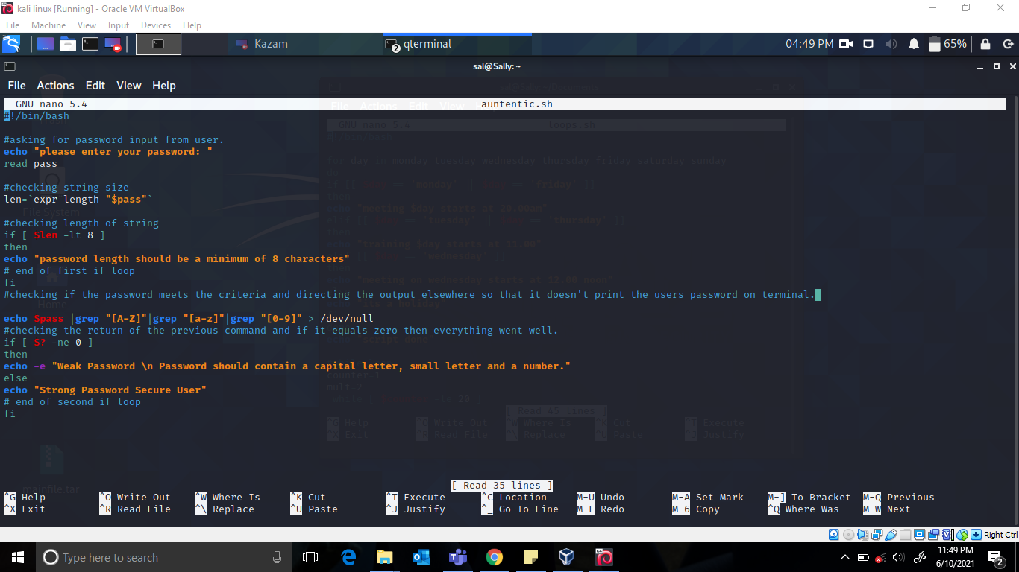

**Output after trying many different passwords:**

